C
www.ceunbdiocese.org

2019
JULY,
CATHOLIC EDUCATION UNIT: YOUR MONTHLY DIARY.
FOR YOUR ATTENTION AND CONSUMPTION
EMMANUEL GAZARI Ag. Planning Officer & Secretary
CATHOLIC EDUCATION UNIT, NAVRONGO-BOLGATANGA DIOCESE.
The Catholic Education Unit in her bid to achieving quality education delivery within the Navrongo-Bolgatanga Catholic Diocese embarks on various activities in the schools within its mandate. For the month of July, the unit has undertaken the following key activities worth sharing with you our cherished stakeholders for your attention and consumption.
Enjoy!
FRIDAY, 5TH JULY, 2019.
HANDING OVER OF HAND PUMP BOREHOLES:
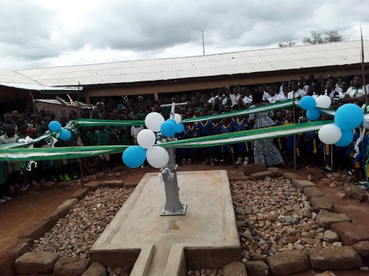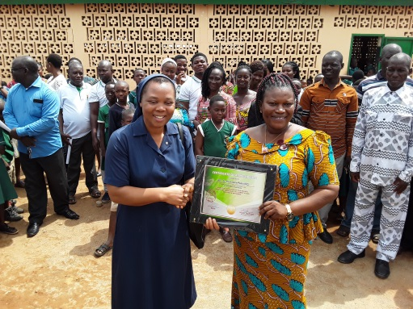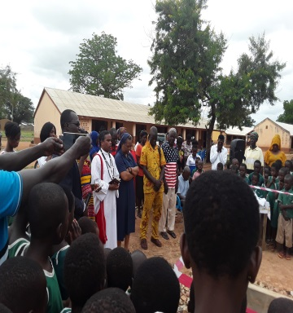
The unit drilled and handed over two hand pump boreholes to St. Clement’s Cluster of schools (Bolgatanga) and St. Francis KG/Primary School (Zaare) both in the Bolgatanga Municipality. The said facilities would benefit close to two-thousand pupils. This was made possible through the support of Mama Nella our benefactor.
Pray for her for the strength to remain steadfast to the needs of unit.
MONDAY 8TH JULY, 2019.
DONATION OF BLESSING OF MOTORBIKE
The Unit’s manager Rev. Sr. Bernardine Pemii, DC donated a Yamaha 125 motorbike as her widow’s mite to the unit to facilitate the movement of field officers.
Your support in any form is also welcome.
May God richly bless her and our benefactors and prospective benefactors.

MON – TUE: 8TH & 9TH JULY, 2019.
WELFARE
The welfare of all matters so much to the unit. As such two days were spared off the usual administrative work to visit our friends and co-workers in various forms of needs. Those visited include Madam Jane Naa Tampa, Rev. Fr. Peter Ayamga, Mr. Bismark Apomuta and the Family of Ernestina

TUESDAY 9TH JULY, 2019.
FAMILIARISATION VISIT TO PRESENTATION BROTHERS SCHOOL COMPLEX @ YIKENE.
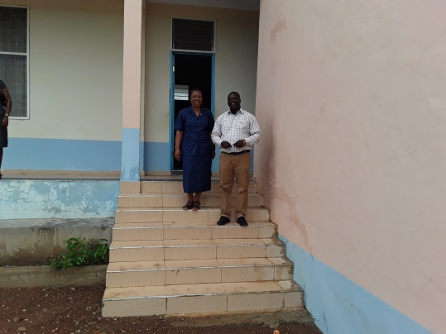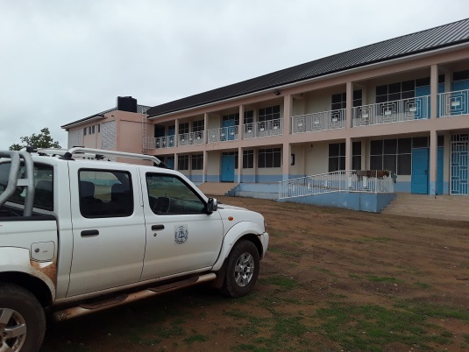
The office paid a familiarization visit to the Presentation Brothers School complex. The school is doing well.
WEDNESDAY 10TH JULY, 2019
VISIT TO ST. PAUL’S SHS – NASIA
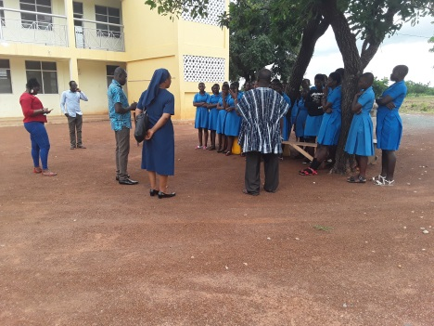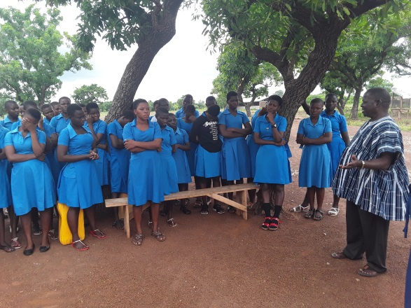
St. Paul’s SHS is a Catholic Private Senior High School located in the St. Paul’s Parish, Walewale.
A team from the Regional Education Unit’s Office and the Chairman of the Diocesan Education Committee, Mr. Paul Apanga paid a working visit to the school to acquaint themselves with happenings in the school and the way forward. The visit was timely and would go a long way to BETTER the GOOD in the school.

THURSDAY 11TH JULY, 2019.
DONATION OF ZINC TO MAURICE BROWN KG/PRIMARY SCHOOL.
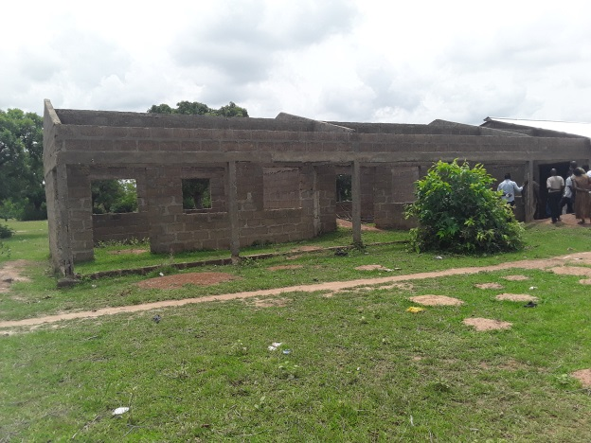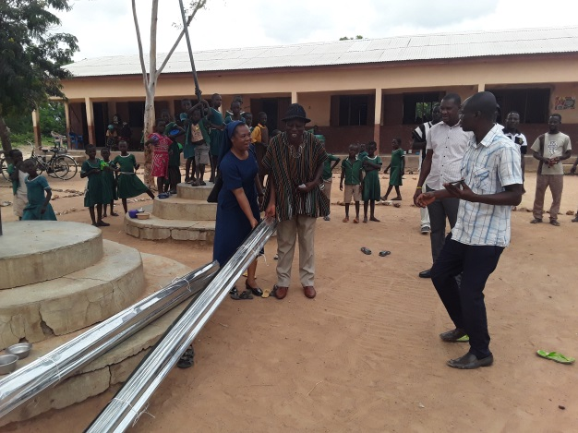
To complement the efforts of the parents of pupils of Maurice Brown KG/Primary Scholl, the unit donated to packets of Galvanized Zinc to the school as its support to the completion of the KG Block being put up through contributions from the parents.
We congratulate the parents and also call on all who mean well to support a good course.
FRIDAY 12TH JULY, 2019
PARTICIPATION IN THE BISHOP’S 2ND ANNUAL LECTURE.
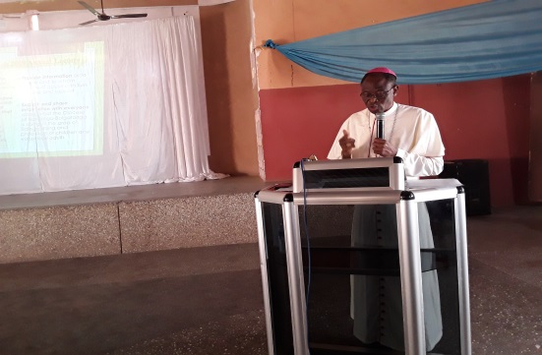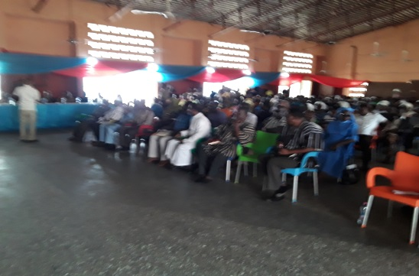
The Bishop’s Lecture is an annual event instituted to enable the Bishop interact with the clergy, lay faithful and society at large on pertinent issues affecting the church and society and as well raise funds to support Seminarians from the Diocese in their formation. This year’s lecture was on the theme: “Confronting the Evil of Abusing Children and Vulnerable Adults: the role of the Church and Civil Society.”
The Unit participated fully at the event with the Manager as one of the Speakers on the theme.

Monday 15th July, 2019
1ST ANNIVERSARY OF CEU CANTEEN AND SEND OFF PARTY FOR GERMAN VOLUNTEERS.
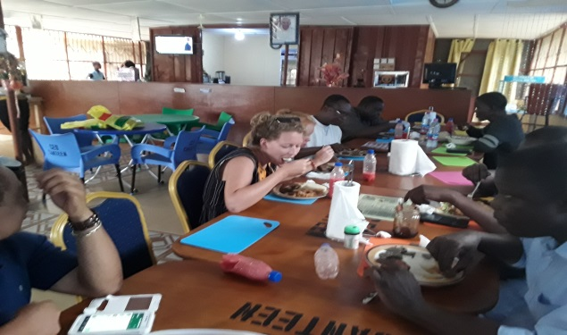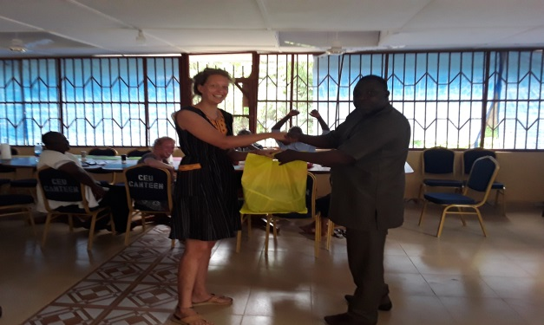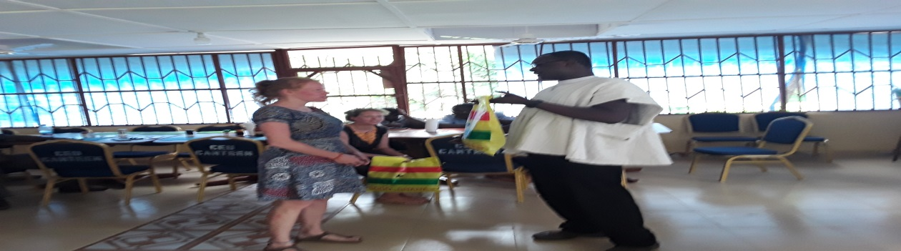
The CEU Canteen which was established last year (2018) on the 10th of July, 2019 was one year old. However, the day could not be marked due to preparations towards the Bishop’s Annual Lecture hence its postponement to the 15th.
You can always rely on the CEU Canteen for the best meals and services. Call us on 0209291820 for your order.
Aside the celebration of the first anniversary, the unit also took the opportunity to organize a send-off party for Madita Kamphaus and Fredericke Huvermann from Münster-Germany who were rounding up their one year stay in the Diocese as volunteers in Fr. James Brown School in St. Martin De Porres Parish (Zuarungu)
We are grateful to the two young ladies for their selfless services to the Diocese and wish them better opportunities as they return to their home country.

MONDAY, 22ND JULY, 2019
HIKING WITH GERMAN VOLUNTEERS.
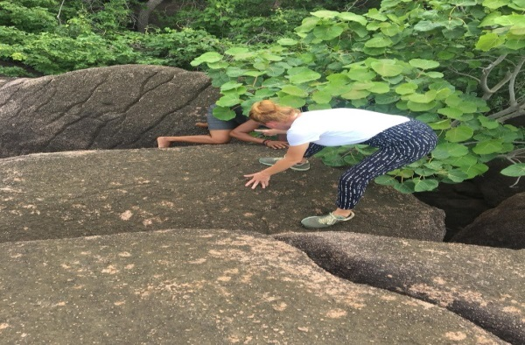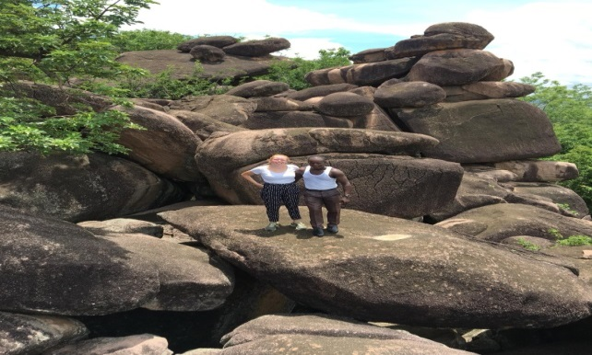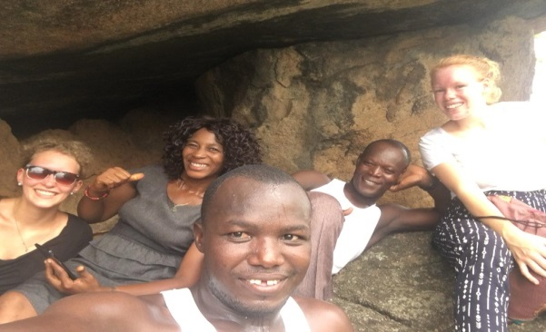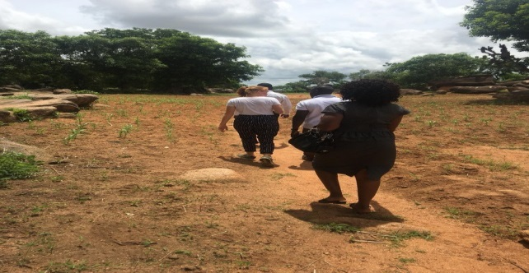
Officers of the Unit took a day hiking in Bongo with the German volunteers. We climbed the Azudoo Hill in Bongo purposely to burnout and relax ourselves by admiring nature.
PARTICIPATION IN GRADUATION CEREMONIES
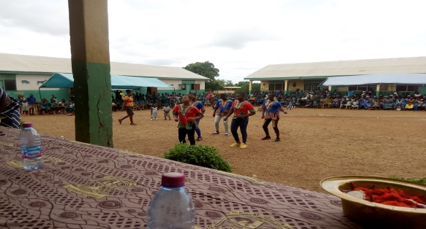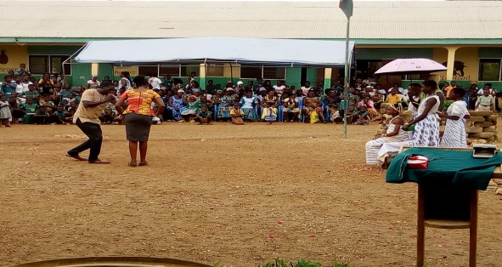
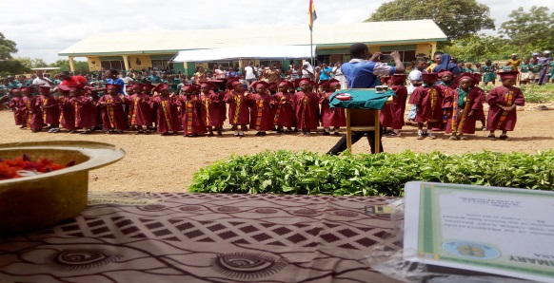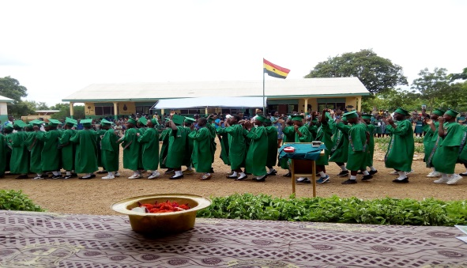
Congratulations to all our schools both private and public that were able to organize graduation ceremonies for their KG2 and P6 pupils.
On the 20th July, 2019, St. John’s International School in Gambibgo had their first Graduation Ceremony. Presentation KG/Primary and Sacred Heart International KG/Primary Schools on the 24th July, 2019 also held their 8th and 2nd Graduation Ceremonies respectively. CEU attended all these. We encourage all our schools to initiate similar events broaden the experiences of the young learners.
DISTRIBUTION OF LOGISTICS
Throughout the month of July, the Unit has distributed about 800 gift boxes to about 12 Parishes for distribution during the 2019/2020 My First Day in School.
Also, two set of computer tables, one teacher’s table and eleven mono desks were supplied to two parishes to facilitate teaching and learning.
CONCLUSION:
We are grateful to our gallant teachers for their show of commitment and sacrifice.
It is the wish of CEU that all stakeholders especially parents would cooperate with the schools to ensure the delivery of quality education for all.
Enjoy your holidays!

