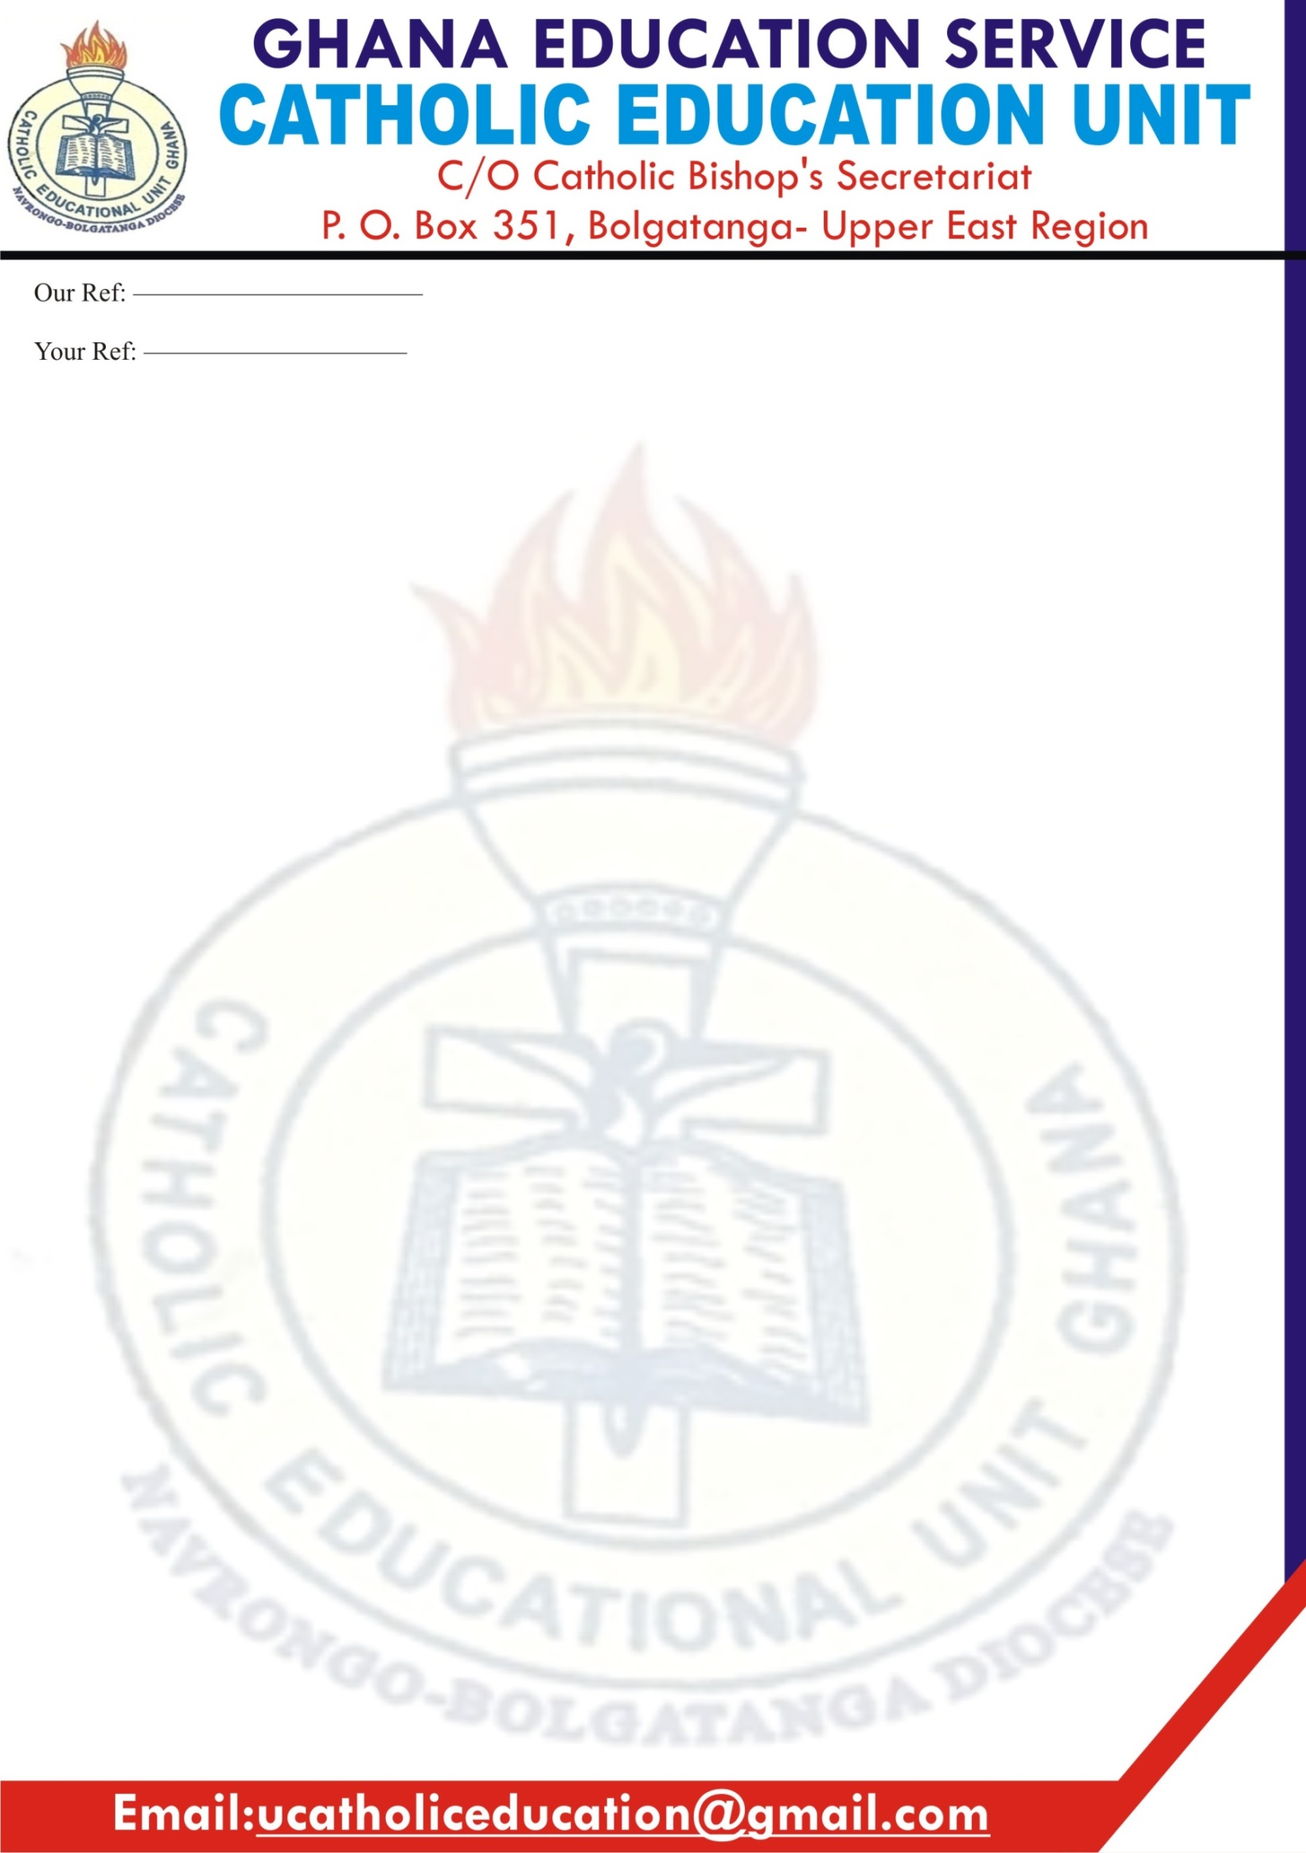

C:\Program Files (x86)\Microsoft Office\MEDIA\CAGCAT10\j0195384.wmf

**16th September, 2019**

**FROM THE REGIONAL MANAGER’S DESK – 2019/2020 ACADEMIC YEAR TO HEADS AND STAFF OF CATHOLIC EDUCATION UNIT INSTITUTIONS NAVRONGO – BOLGATANGA DIOCESE**

**Introduction:**

God has been faithful to us throughout the just ended academic year and we are blessed to be among the living to commence this new academic year – 2019/ 2020. I know most of us had little time to rest as we were in the school for the sandwich program and having to run back for the training on the new curriculum. All the same, we thank God for everything.

**Appreciation**

I am sincerely grateful to each of you for the sacrifices you continually make in your ministry as teachers either in the classroom or in administration. I appreciate the Regional Director and all the Municipal/District Directors of Education within our Diocese for their support and collaboration.

**Condolences**

Within the just ended academic year, we lost students, teaching and non-teaching staff from our Unit Schools to the cold hands of death. May God grant the deceased eternal rest, comfort and consolation to their families and the school communities to which they belonged.

**Health check for teachers**

Last year, we sponsored a health screening exercise for staff of our Unit schools; unfortunately the patronage at the first few schools visited was not encouraging so the exercise was discontinued.

**Brain Battle Quiz**

The Unit is organising a Regional quiz competition for the present Form 3 students in collaboration with Cocktail Media. The date is 26th of September, 2019 at the Our Lady of Africa (OLA) Parish premises. The 12 competing schools know themselves and we are all encouraged to come and support them.

**Child Protection Delegates**

Another reminder for each school to give us the name of the teacher delegated to be our contact person on Child Protection. This is to enable us organise a training for them to equip them for the task.

**Spiritual exercises for teachers and students/pupils**:

Let us remind ourselves of the need to celebrate the Eucharist at the start and ending of term, the Angelus at 12noon and the school’s feast day.

**Catholic Week Celebration**

Note that the Catholic Week celebration for next year comes up between Sunday 26th January 2020 and Sunday 2nd February, 2020. The materials will be distributed later in the year.

**New Teachers at the Regional Office:**

I welcome all the teachers who have been posted to our Unit schools either as newly trained teachers or on transfer. I welcome especially the 2 new teaching staff added to the Regional staff strength – Mrs. Rose Atubila – the Human Resource Officer and Mr. Emmanuel Gazari – the Planning Officer.

**New Curriculum Implementation:**

Despite the seeming confusion on the new curriculum, let us be patient with the system and with ourselves as this new curriculum is rolled out. Remember at the center of all these is the **CHILD**; not you, not the Ghana Education Service, not the Ministry of Education and so on. The welfare of the child must therefore be placed above all other concerns and sentiments. As implementers, THINKING OUTSIDE THE BOX should be our best tool in the implementation process so that we overcome these challenges and succeed.

**Data Collection:**

We will, as usual be coming round to issue the data collect form for staff and pupils/students from your schools so counting on your usual support. This year’s data collection form has additional information i.e. school needs. You are required to provide the unit with three most pressing needs of your school. This information is used to furnish the Catholic Bishop of the Diocese, their Conference and the Nuncio for Rome and informs our intervention strategies.

**The Unit’s Website:** Thankfully, the website for the unit ([www.ceunbdiocese.org](http://www.ceunbdiocese.org)) is now very active and with monthly updates of CEU activities and other relevant information. You are invited to always log in to update yourself with happenings in and around the unit. If you have any story to share in the interest of the Unit, the Church or Ghana Education Service, you may send it through your deanery coordinator, or to the following e-mail addresses ([royalgaza@gmail.com](mailto:royalgaza@gmail.com) or [ucatholiceducation@gmail.com](mailto:ucatholiceducation@gmail.com)) and we would gladly review and publish it for you.

**The Association of Catholic Teachers.** In November, 2016 the Association of Catholic Teachers was inaugurated here in our Diocese. My office has observed that a lot of teachers out there who are Catholics are yet to join the association. I encourage you to get in touch with the leadership and register your membership since the Unit office relies so much on ACT for its human resource needs.

**Conclusion**

I am, by this letter encouraging all Local Managers and Chaplains to closely supervise the activities at our Unit schools to support the Heads, curb excesses and promote holistic education.

May God take the lead while we remain His hands, legs and voices – **‘One Day’** at a time.

Yours faithfully,

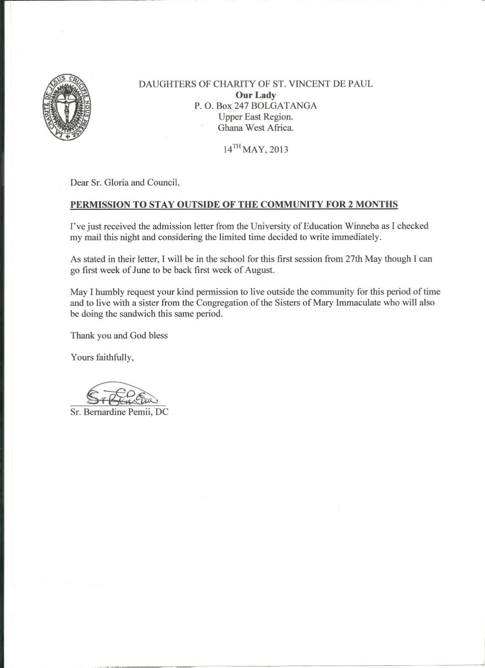

AG Regional Manager, Catholic Education Unit

Cc:

The Bishop, Most Rev Alfred Agyenta – **Bolgatanga**

The General Manager, Catholic Education Unit – **Accra**

The Regional Director of Education – Upper East Region- **Bolgatanga**

The Regional Director of Education – Northern Region- **Tamale**

All Local Managers and Chaplains– Navrongo – Bolgatanga Diocese-

All Heads of Catholic Education Unit Institutions