Always contact us on: ucatholiceducation@gmail.com
Compiled by:
Emmanuel Gazari
IN THIS DIARY:
CEU STAFF VISIT CATHOLIC SCHOOLS
THE BRAIN BATTLE REGIONAL CHAMPIONS CALLS ON BUILSA NORTH EDUCATION DIRECTORATE
MOVEMENT OF GERMAN VOLUNTEERS FACILITATED
THE CATHOLIC CHURCH SCHOOLS STAKEHOLDERS ON NATIONAL REFERENDUM
CAUTION
CALL FOR ADMISSIONS.
OCTOBER, 2019

CATHOLIC EDUCATION THIS MONTH
YOUR MONTHLY DIARY

OUR FUTURE LEADERS, POISED FOR LIFE-LONG LEARNING

CATHOLIC EDUCATION UNIT: NAVRONGO-BOLGATANGA DIOCESE.
INTRODUCTION:
Permit me to fill you in on our activities for the month of October 2019. Always at your beck and call.
CEU STAFF VISIT CATHOLIC SCHOOLS
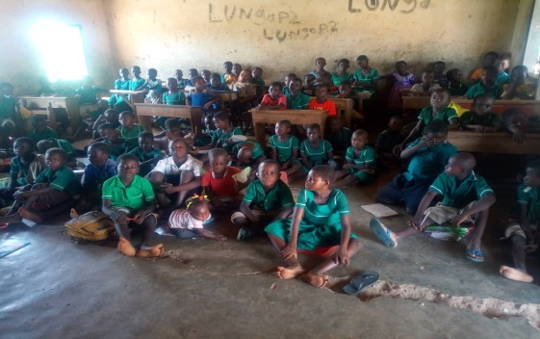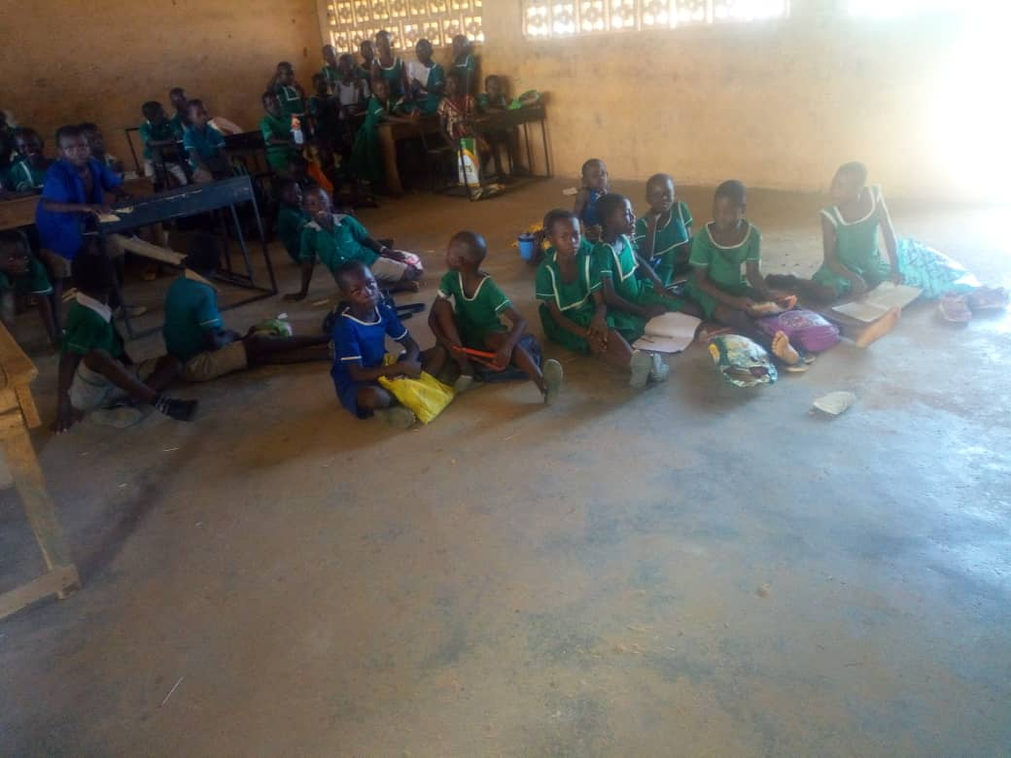

The unit’s staff took time out of their busy schedules to visit all the three hundred and fifty – one schools across the Diocese. The visits were intended to welcome the staff, pupils and students back for the 2019/2020 Academic Year, familiarize with the new entrants that is both teachers and learners, assess the implementation of the New Standards Based Curriculum; its successes and challenges and deliver the Annual School Data Capture Forms as well as attend to other issues that required immediate attention.
It was a hectic but refreshing exercise as the team met new faces, received success stories and also saw for ourselves the challenges our gallant teachers go through in the discharge of their duties. Under staffing, inadequate source materials, staff accommodation, inadequate school structures among others are the challenges that faces our schools.
We are also grateful to the Government for extending the School Feeding Programme through the various MMDAs to some of our schools. THANK YOU.

Any form of support regards these challenges would be highly appreciated.
THE BRAIN BATTLE REGIONAL CHAMPIONS CALLS ON BUILSA NORTH EDUCATION DIRECTORATE
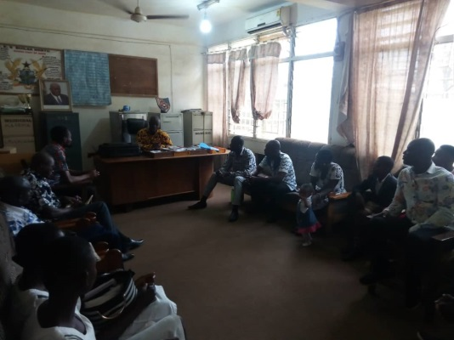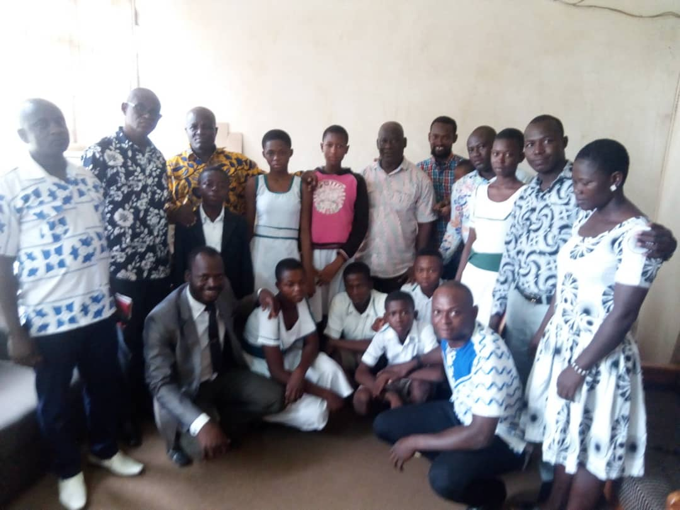

Fervent preparations are underway for the Region to face it off with other Regions in the Brain Battle Quiz for the National Champion in Accra at a later date this year.
The Brain Battle Quiz is a National Science and Math Quiz organized by the National Catholic Secretariat and “The Cocktail”, a Catholic Youth Media based in Accra and Kumasi with the aim of demystifying the learning of math and science with fun activities. The Upper East Region was privileged to be part of this and had its turn of the Regional Championship on the 26th September, 2019 at the Rev. Fr. Patrice Gasser’s Hall in OLA Parish, Bolgatanga. At the end, Christ the King JHS and Chiok JHS both in Builsa North District proved that, after all the best can also be found in rural areas. They made it, to represent the Region at the National Contest in February 2020 during which the 2020/2021 Championship would be launched.
As part of preparations towards the national Contest, two Officers from the Unit Office, Emmanuel Gazari and Prosper Abotzabire together with the Heads of the two schools and their Math and Sciences teachers called the Builsa North Municipal Education Director and his staff to introduce the Champions to them. The team also briefed the Directorate about the contest; shared our challenges as far as the preparations are concerned.
It was a very interactive and fruitful session and the Director gave his blessings and pledged his support for the success of the programme
The competition is set to continue next year and in subsequent years.

THE CATHOLIC CHURCH SCHOOLS STAKEHOLDERS ON NATIONAL
REFERENDUM
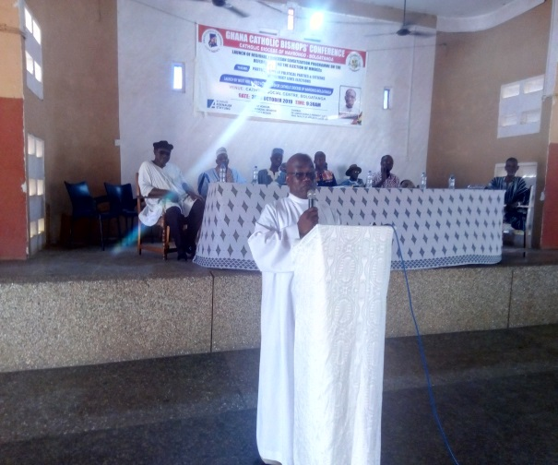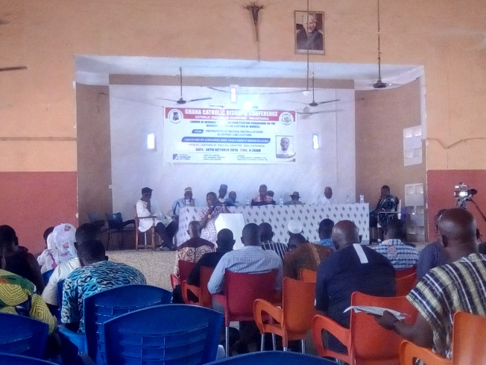
The Catholic Diocese of Navrongo-Bolgatanga Diocese under the auspices of the Ghana Catholic Bishops’ Conference as part of its civic responsibilities to the nation on Wednesday 30th October, 2019 through the Good Governance, Justice and Peace Commission (GGJPC) launched the Regional/Diocesan sensitization programme on the referendum and election of MMDCEs on the theme: “Participation of Political Parties and Citizens in District Level Elections.”
The forum sought to enlighten participants and bring clarity on the misinformation on the said referendum and to charge them to step it down to their various parishes, groups and institutions.
The staff of the Catholic Education Unit attended this all-important function.
MOVEMENT OF GERMAN VOLUNTEERS FACILITATED
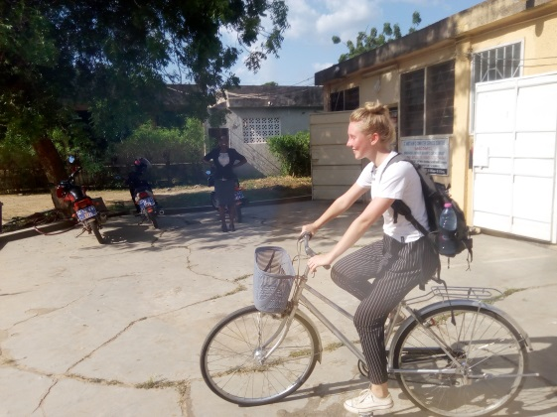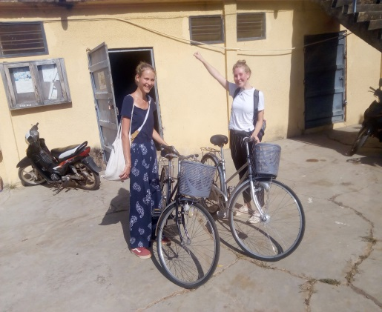
The unit purchased two bicycles for Hana and Lena our Volunteer from Germany. This is aimed at facilitating their movements to and fro OLA to other destinations they may be visiting especially the Next Generation Home and St. Charles’ Special School where they have expressed interest in extending their services to.

CAUTION

We wish to caution our school heads and staff to be weary of the activities of some NGOs in the schools. We have observed that some of the NGO Programmes and activities flauts the principles and values of Catholic Education. We encourage them to always alert the office once an NGO is given approval to roll out a programme. Project or activity in any of our schhools.

CALL FOR ADMISSIONS:

It is announced for the information of the general public that, St. Paul’s Senior High School has vacancies for prospective applicants. The school has boarding facilities for both boys and girls and is located in a serene environment. The best of Catholic Education (Holistic Education) is offered to students.

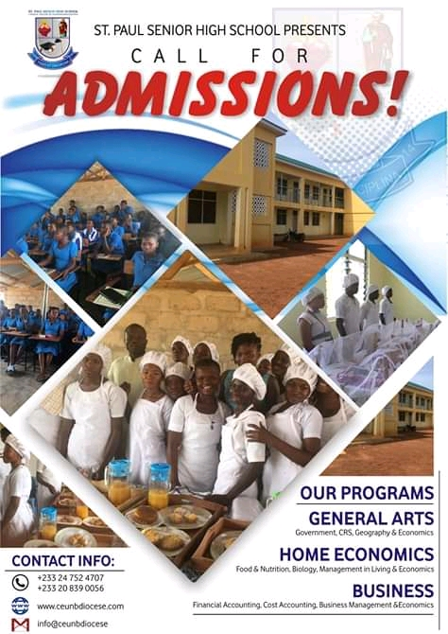

If you have any story to publish, kindly contact us on, royalgaza@gmail.com or ucatholiceducation@gmail.com and we would gladly do.

